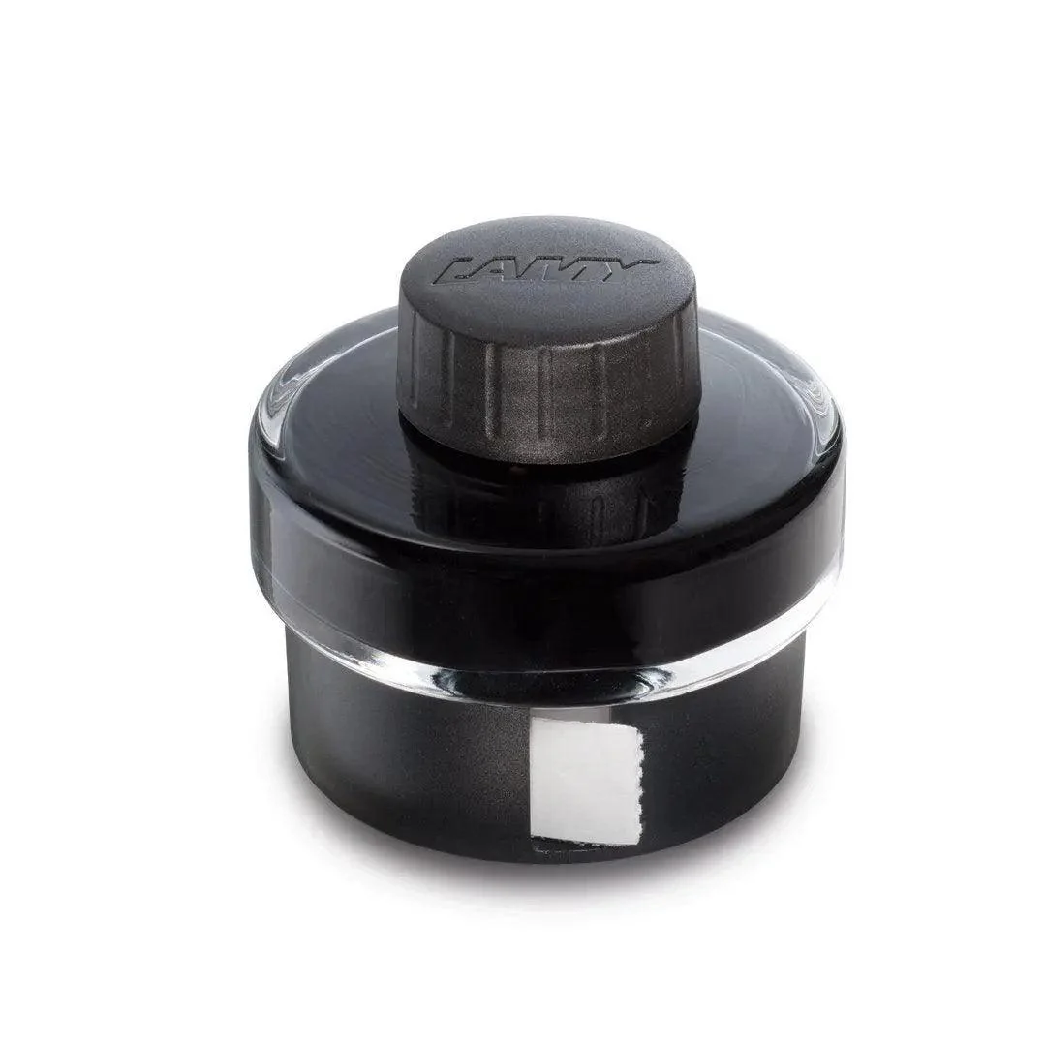

**LAMY T52 bottled ink**

LAMY T 52 bottled ink, 50ml, comes with an in-built roll of blotting paper around the base and ink residue collecting basin for effortless and mess free refilling of your fountain pen. Available in a variety of colours and specifically engineered to suit LAMY fountain pens.